An-Najah National University Faculty if IT & AI
Department of Computer Science Design and Analysis of Algorithms - HW#1

Write a complete program that inputs two undirected graphs from the user and stores each graph in 3 different ways (representations) as explained in the example below.
- Your program must display the edges of the graph - as shown in the example below- from any representation chosen by the user to make sure that it is entered properly.
- Your program must be able to determine: The intersection between the graphs (common edges), The union of the graphs (all edges without repetition), whether one graph is a subgraph of another, the vertex (vertices) with the highest degree, whether the two graphs are equal (the same graph) or not.
Example:
Graph A Graph B
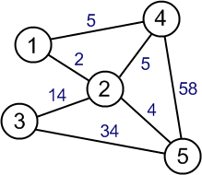
5
1
4
5
58
3
2
5

The intersection between the graphs has the edges: (1,4), (2,4), (5,4)
The union of the two graphs has the edges: (1,4), (2,4), (5,4), (1,2), (2,5), (2,3), (3,5) Graph A is not a subgraph of graph B.
Graph B is a subgraph of graph A.
The vertex (vertices) with the highest degree in graph A: 2 with the degree of 4 The vertex (vertices) with the highest degree in graph B: 4 with the degree of 3 The two graphs are not equal (not the same graph).
Note: This is just an example. Your program must be able to input and deal with any other undirected weighted graphs.

User Interface:
Please enter the number of nodes in graph A:

Please enter the number of edges in Graph A:

Please enter edge1 and its weight in the order (vertex1, vertex2, weight): Please enter edge2 and its weight in the order (vertex1, vertex2, weight):
………………………..

// the same is done to enter the data of graph B Please select one of the following:
  - Output graph A from the array of lists
  - Output graph A from the matrix
  - Output graph A from the array of structures/objects.
  - Output graph B from the array of lists
  - Output graph B from the matrix
  - Output graph B from the array of structures/objects.
  - The intersection between both graphs
  - The union of the two graphs
  - Is graph (A) a subgraph of graph (B)? // outputs yes/no
  - Is graph (B) a subgraph of graph (A)? // outputs yes/no
  - Display the vertex (vertices) with the highest degree from graph A.
  - Display the vertex (vertices) with the highest degree from graph B.
  - Are the graphs equal (the same graph)?
  - Exit program
Your program must keep on displaying the above list and giving the desired output until the user chooses (14).

Example of graph input and representation:
Note: This graph is just an example. Your program must be able to input and deal with any other undirected weighted graph.


Input: (the user input is shown in red)
Please enter the number of nodes:
5
Please enter the number of edges:
7
Please enter edge1 and its weight in the order (vertex1, vertex2, weight): 1
4
5
Please enter edge2 and its weight in the order (vertex1, vertex2, weight):
1
2
2

Please enter edge3 and its weight in the order (vertex1, vertex2, weight):
2
4
5
Please enter edge4 and its weight in the order (vertex1, vertex2, weight):
4
5
58
Please enter edge5 and its weight in the order (vertex1, vertex2, weight):
2
5
4
Please enter edge6 and its weight in the order (vertex1, vertex2, weight):
2
3
14
Please enter edge7 and its weight in the order (vertex1, vertex2, weight):
5
3
34
Now your program stores the above graph in the following formats: 1- An array of structures/objects:

0 | 1 | 2 | 3 | 4 | 5 | 6
V1:1 V2:4  Weight:5 | V1:1 V2:2  Weight:2 | V1:4 V2:2  Weight:5 | V1:4 V2:5  Weight:58 | V1:2 V2:5  Weight:4 | V1:3 V2:5  Weight:34 | V1:2 V2:3  Weight:14

- A matrix:
 | 1 | 2 | 3 | 4 | 5
1 | 0 | 2 | 0 | 5 | 0
2 | 2 | 0 | 14 | 5 | 4
3 | 0 | 14 | 0 | 0 | 34
4 | 5 | 5 | 0 | 0 | 58
5 | 0 | 4 | 34 | 58 | 0

Note1: the number zero means that the edge does not exist, the numbers in red are the weights of the edges.
Note2: The graph is undirected. Edge (1,2) and edge (2,1) are the same edge (you have to fill both in the matrix).

- Array of linked lists:
degree for 1 is ? 2 (Number of neighbours)

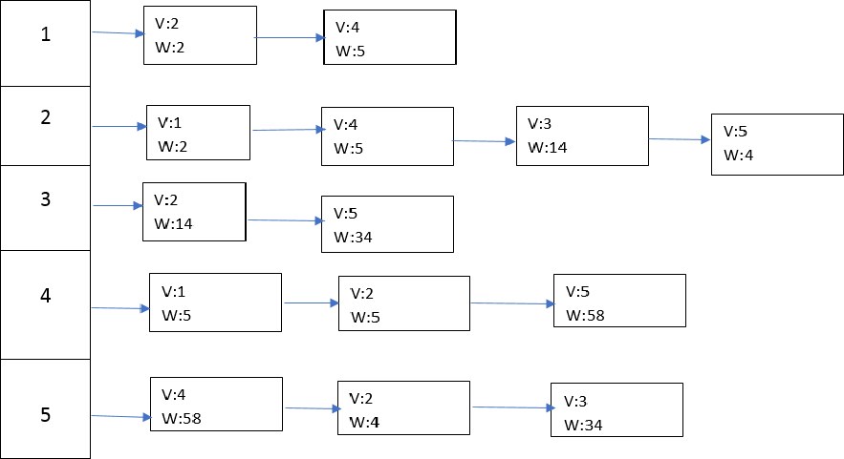

Output (all methods must give the same set of edges):
The edges are:
Edge (1,2) has the weight of 2 Edge (2,1) has the weight of 2 Edge (1,4) has the weight of 5 Edge (4,1) has the weight of 5 Edge (2,4) has the weight of 5 Edge (4,2) has the weight of 5 Edge (2,3) has the weight of 14 Edge (3,2) has the weight of 14 Edge (2,5) has the weight of 4 Edge (5,2) has the weight of 4 Edge (5,3) has the weight of 34 Edge (3,5) has the weight of 34 Edge (4,5) has the weight of 58 Edge (5,4) has the weight of 58

